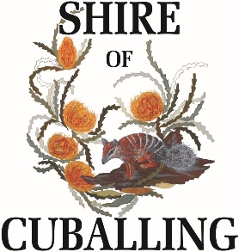
Application for Rural Road Numbering
Please return form to rates@cuballing.wa.gov.au or at the Shire Office

Applicant Details
Name of Owner
Street Address
House/Street Number |  |  | Lot Number
Certificate of Title |  |  | Plan Number
Contact Details
Mobile Number |  |  | Phone Number
Email Address
My property contains one of the following:
Farm House/Dwelling |  | Machinery Shed
Shearing Shed |  | Temporary House
New House with proof of Building Permit
If the above options don’t apply, please explain why you are applying for a rural road number:
Owner Signature: | Date
Owner Signature: | Date
Office Use Only
Receiving Officer |  |  | Signature
Assessment No. |  |  | Date
Rural Road Number |  |  | System Updated | YES / NO

