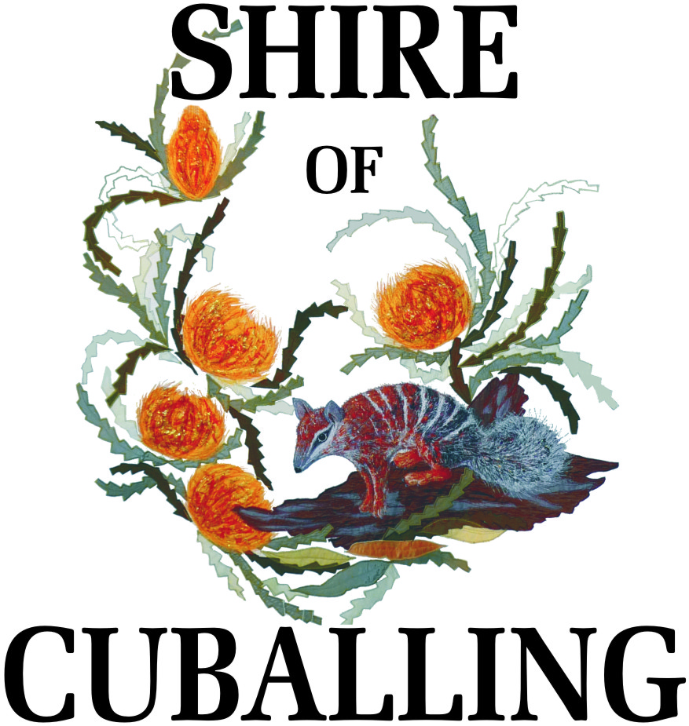
Application for Permission to Serve Alcohol on Council Property

Must be authorised by the Chief Executive Officer of the Shire of Cuballing
You must obtain permission from the Shire of Cuballing to serve/consume alcohol on Council Property. If you plan to sell alcohol, an occasional Liquor Licence is also required. It is your responsibility to obtain the Occasional Liquor Licence. These can be obtained from the Narrogin Court House and must be displayed at your event.

APPLICATION DETAILS
Venue:
Date:
Function:
I/We Request permission to:

☐ |  | Serve and Consume Alcohol
☐ |  | Consume (BYO) – Patrons Supplying Own Liquor Only
I agree that should this request be approved; the following conditions apply:

 | 1. | The requirements of the Liquor Licensing Act being fully complied with
 | 2. | No Alcohol being consumed outside of the Premises
 | 3. | Liquor is to be consumed in an orderly manner
 | 4. | No liquor will be served to or consumed by persons under the age of 18 years
 | 5. | that the person obtaining the permit shall ensure that all rubbish is placed in the receptacles provided before departing the property
Signed: |  |  |  |  | Date:

OFFICE USE ONLY

Authorisation: |  | Granted on:
 | Chief Executive Officer

