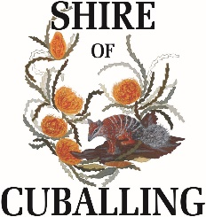
FACILITY HIRE FORM
Name/Organisation:
Contact Person: |  |  |  | Mobile No. :
Billing Address:
Email Address
Purpose of Function:
Start Date: |  |  |  | End Date:
Times From/To:
Days: |  | Mon Tues Wed Thur Fri Sat Sun
Please tick venue required
Venue: |  |  | Rates
 |  |  | Per Hour |  |  | Per Day/Night
Cuballing Agricultural Hall
Minor Functions |  |  | N/A |  |  | $150.00
Major Functions |  |  | N/A |  |  | $300.00
Cuballing Recreation Centre
Minor Functions |  |  | N/A |  |  | $139.00
Major Functions |  |  | N/A |  |  | $278.00
Use of Oval and/or Kitchen – Hourly |  |  | $33.00 |  |  | N/A
Use of Toilets/Showers |  |  | N/A |  |  | $155.00
Use of Oval |  |  |  |  |  | $70.00
Popanyinning Hall
Minor Functions |  |  | N/A |  |  | $150.00
Major Functions |  |  | N/A |  |  | $300.00
Popanyinning School
Minor Function |  |  | N/A |  |  | $150.00
Cuballing CWA |  |  | $30.00
Bonds – There is a Bond for all Facilities within the Shire of Cuballing
Bond – Without Liquor |  |  |  |  |  | $100.00
Bond – With Liquor |  |  |  |  |  | $150.00
If you will be selling alcohol you will require a liquor licence from Clerk of Courts.

I/We agree to the conditions set by the Shire of Cuballing for the hire of the venue noted above and understand that if the premises are left in any condition other than acceptable I agree to reimburse the Shire of Cuballing any costs incurred.

I/We agree to indemnify the Shire of Cuballing against all actions, claims, demands and costs arising out of or in connection with the hire of this facility.
Signed: |  |  |  |  | Date:
Office Use Only

Alcohol Consumption Approved: ____________________________ File No. ADM77/78
Chief Executive Officer

Terms and Conditions of Hiring
Bookings: | Bookings are to be made via the Shire Administration Office for all events. In the event of a cancellation, please contact the Shire Office as soon as possible.
Cleaning: | The hall and immediate surrounds should be left in a clean and tidy condition after use, including removal of all decorations. Please ensure floors are swept and rubbish is placed in the outside bins. If appliances are used (i.e.: Fridges, oven etc) they must be left in a clean condition.  The Shire of Cuballing will charge the hirer for any additional cleaning at $92 per hour.
Equipment  Crockery, Cutlery, Glasses | Please ensure all items used are cleaned and replaced. Any electrical equipment used in the kitchen should be cleaned and stored correctly.
Tables & Chairs | Tables and Chairs are supplied as part of the hire fee. Please ensure they are cleaned and returned to the storage area. Chairs are to be stacked in piles no higher than 10, tables are to be folded and stored in upright position.
Damage | The hirer should inform the Shire if there is any damage noticed prior to your event. If any damage occurs during your event, Council will seek to recover the full value of damage or repair costs from the hirer.
Decorations | Driving screws and nails etc into any part of the building fixtures is strictly prohibited. All decorations must be removed immediately after the function. No decorations are to be fixed to heating or air conditioning appliances.
First Aid | It should be noted that Council does not provide a First Aid assistant or supplies within the facility. It is the hirers responsibility to ensure adequate supplies are available at the event.
Alcohol | If you are selling alcohol, a liquor licence needs to be obtained from the Clerk of Courts and presented to the Shire Administration Office prior to the event.
Noise | Please ensure loud music is kept to a minimum at a reasonable hour. The hirer is responsible to ensure all patrons leave the venue and its surrounds immediately after the function, in a quiet and timely manner.
Payment | Payment is required prior to the event for private functions. Organisations and community groups can request that an invoice be issued.
Refusal | The Shire of Cuballing reserves the right to refuse to let the facility or any portion of the facility without assigning any reason.
Smoking | The Shire of Cuballing prohibits smoking inside all council owned facilities. Please encourage all patrons utilise the ashtrays placed outside on verandas to reduce clean-up for council staff
Sleeping in the Building | Sleeping/Camping in the building is not permitted unless authorised by Council.

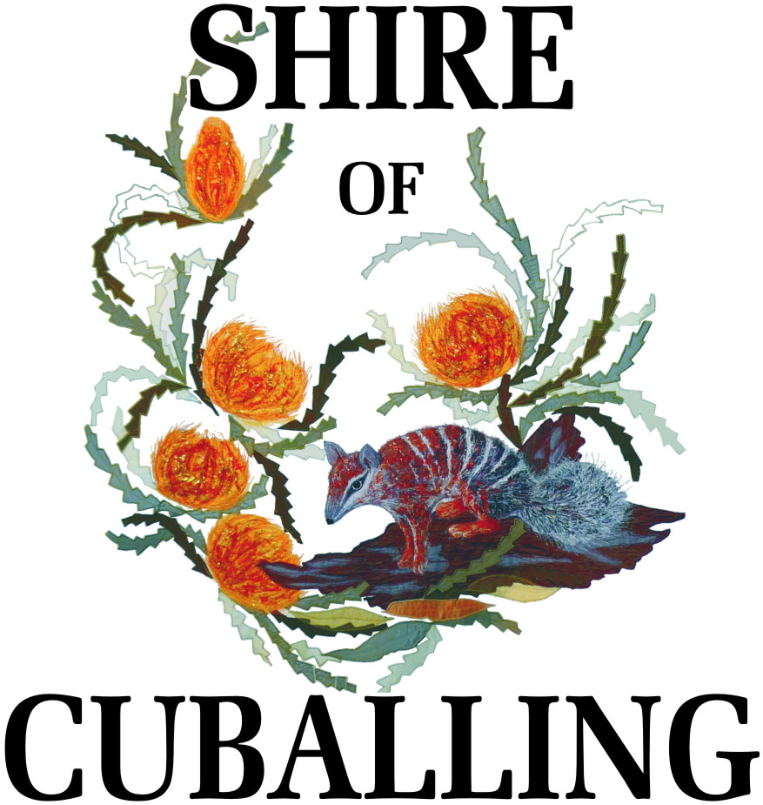
Application for Permission to Serve Alcohol on Council Property

Must be authorised by the Chief Executive Officer of the Shire of Cuballing
You must obtain permission from the Shire of Cuballing to serve/consume alcohol on Council Property. If you plan to sell alcohol, an occasional Liquor Licence is also required. It is your responsibility to obtain the Occasional Liquor Licence. These can be obtained from the Narrogin Court House and must be displayed at your event.

APPLICATION DETAILS
Venue:
Date:
Function:
I/We Request permission to:

☐ |  | Serve and Consume Alcohol
☐ |  | Consume (BYO) – Patrons Supplying Own Liquor Only
I agree that should this request be approved; the following conditions apply:

 | 1. | The requirements of the Liquor Licensing Act being fully complied with
 | 2. | No Alcohol being consumed outside of the Premises
 | 3. | Liquor is to be consumed in an orderly manner
 | 4. | No liquor will be served to or consumed by persons under the age of 18 years
 | 5. | that the person obtaining the permit shall ensure that all rubbish is placed in the receptacles provided before departing the property
Signed: |  |  |  |  | Date:

OFFICE USE ONLY

Authorisation: |  | Granted on:
 | Chief Executive Officer

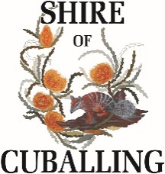
Reimbursement Form

First Name
Last Name
Postal Address
Phone Number
Email Address
Banking Details:
Name of Account
Name of Bank
BSB |  | Account Number
Reason for Refund
Items/Services to be Reimbursed
 |  |  |  | Cost $
 |  |  |  | Cost $
 |  |  |  | Cost $
Total = $
Signature Date
Office Use Only
Refund Approved | □ Yes □ No |  | Approved by
Receipts Provided | □ Yes □ No |  | Date of Approval
Refund Amount | $ |  | Officer’s Signature
Notes

EMERGENCY CONTACT NUMBERS

SHIRE OFFICE  MON – THU, 8.30AM – 4.30PM,  FRI 8.30AM – 4.00PM | 9883 6031
MANAGER OF WORKS & SERVICES | 0427 836 063
NARROGIN POLICE | 9882 2555
AMBULANCE & FIRE | 000

