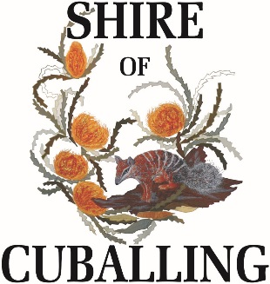 |  | POSITION DESCRIPTION  Cleaner
Division: | Chief Executive Officer: |  | Direct Supervisor: | Employment Status | Award Level:
Works | Gary Sherry |  | Bruce Brennan | Casual | As per LGIA 2010

Purpose:
The purpose of this role is to clean public buildings within the Shire of Cuballing in order to keep facilities in a clean, tidy and useable condition.

Role Requirements:
Skills
- Verbal and written communication skills
- Established interpersonal skills
- Focus on attention to detail and accuracy in all facets of work.
- Demonstrated understanding of the need for prioritising, scheduling and monitoring multiple tasks / processes

Knowledge
- Demonstrated customer service ability
- Demonstrated understanding of Local Government roles and responsibilities

Experience/ Qualifications
- Demonstrated experience in a similar role
- Current ‘C’ Class licence

Key Duties/ Responsibilities
Cleaning Duties
- Maintain and clean public buildings as directed, as per the schedule of works
- Clean and supply designated facility areas (dusting, sweeping, vacuuming, mopping, restroom cleaning etc)
- Perform and document routine inspection and maintenance activities
- Report any damage or maintenance requirements of facilities to Council’s Manager of Works and Services for action
- Follow all health and safety regulations
- Understand, refer to and abide by Councils policies, procedures and work practices

Selection Criteria
Essential
- Basic written, oral and interpersonal skills
- Proven ability to organise time effectively and work with limited supervision
- Current ‘C’ Class licence

Desirable
- Demonstrated understanding of Local Government roles and responsibilities

Key Role Relationships
Internal
- Chief Executive Officer
- Deputy Chief Executive Officer
- Administration Staff
- Works Supervisor
- Works Staff
External
- Local residents

Employee Certification: | Date:
Supervisor Certification: | Date:
Review Date:

