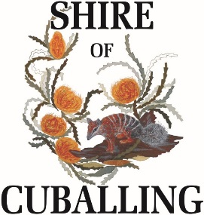
GIFT REGISTER & CONTRIBUTIONS TO TRAVEL
Section 5.87C of the Local Government Act

Name of relevant person making disclosure | Description of contribution | Name of person who made contribution | Address of person who made contribution | Date contribution was received | Estimated value of contribution at time it was made | Nature of relationship between relevant person and person who made contribution | Description and Date of travel | For an excluded gift under s,5.62(1B)(a) – the date of the approval referred to in s,5.62(1B)(a)(ii) and the reasons for the approval
Sue Hann | Orchid Plant and 2 boxes of Chocolate | Julie Carlson | N/A | 08/01/2026 | $40.00 | Ratepayer | N/A | N/A
Careese Ranieri | 2 x Mower Blades | Norm Potter | N/A | 30/01/2026 | $60.00 | Ratepayer | N/A | N/A
Rob Harris | Travel to PHCC Meeting | Peel Harvey Catchment Council | 58 Sutton Street, Mandurah | 30/06/2025 | $343.20 | Member of PHCC | 19/06/2025 | N/A

