Cuballing Railway Reserve.

The Shire of Cuballing is undertaking a review of the central rail reserve in the townsite of Cuballing to have a strategy in place for future improvements. The most successful places are ones that are well used by the local community and reflect their needs and wants.

With this in mind, the Shire is seeking feedback through a survey on what improvements the local community would like to see within the rail corridor. The ideas and suggestions from this survey will inform the preparation a strategic concept plan that will seek co-ordinate future improvements to maximise the amenity and public use of the rail reserve by local residents, tourists and travellers.

We hope you will complete all parts of the survey, which should take about 5 minutes.

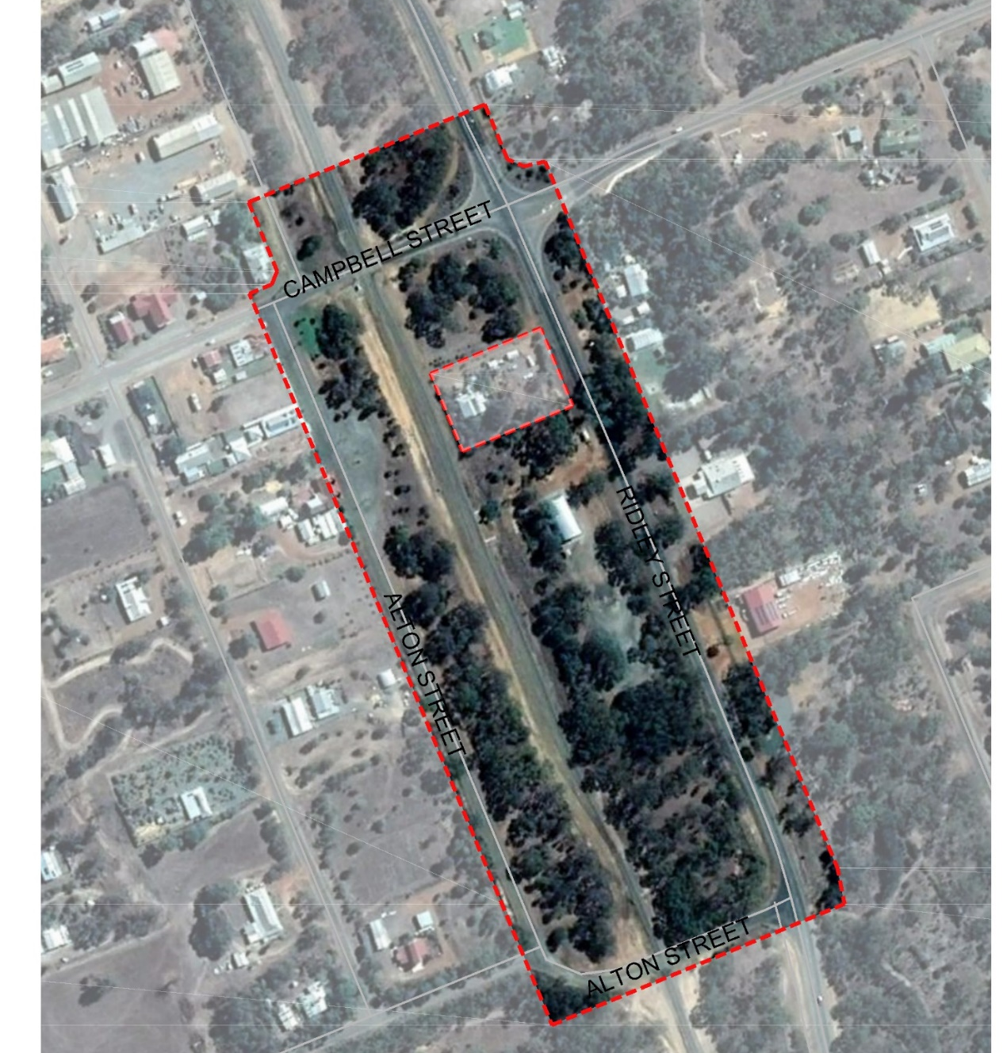

The Shire will also hold a Workshop at 5pm on Tuesday 25th August in the Cuballing Town Hall to discuss options for the including in the review.
Survey Questions

1. Town centres can be a great representation of the type of community that resides within its boundary. We want to understand what Cuballing means to you. Please let us know up to three (3) things that you always respond with when someone asks you about what you love about Cuballing.
a. _______________________________________________________________
b. _______________________________________________________________
c. _______________________________________________________________

2. When we travel, local, nationally or internationally we always see places and things that we love and think ‘I wish we had one of these back home’. With this in mind: If you could add one thing to Cuballing town centre what would it be?
___________________________________________________________________
___________________________________________________________________
___________________________________________________________________

3. A town centre is the public heart of a community. How often do you visit Cuballing town centre and what do you do when you are there?
How Often __________________________________________________________
What do you do? _____________________________________________________
___________________________________________________________________
___________________________________________________________________

4. What would encourage you to visit the town centre more often and stay longer?
___________________________________________________________________
___________________________________________________________________
___________________________________________________________________
___________________________________________________________________

We thank you for your input.

If you have any questions about the survey, or would like to provide input into the concept plan through other means, we can be contacted:
- on 08 9883 6031
- at enquires@cuballing.wa.gov.au
- by calling into the Shire Office.

